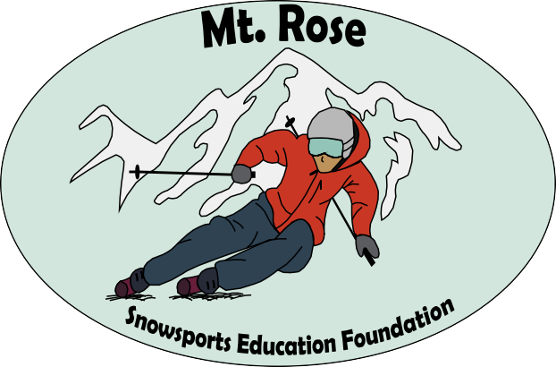


The Mt Rose Snowsports Education Foundation has a mission to support the Pursuit of Excellence for Athletes to develop Potential, Character, and Lifelong skills. We value the USSA Code of Conduct, Sportsmanship, Purpose, Integrity, Self-Discipline, and Resiliency among athletes. We have a commitment to support the Mt Rose Ski Team, as our coaches develop athletes from our Lake League, Free Ride Competitive, and Alpine Race Teams.
The MRSEF board is made up of coaches, parents, Masters Athletes, and community members whose love of ski racing, giving back to our community and pride in our Mt Rose Athletes go hand in hand.
To learn more about our foundation, please go to www.mrsef.org.

It is with great pleasure that we offer our 2025/2026 scholarship opportunities to Mt Rose Athletes to help defray the costs of ski racing and others by invitation to divisional, regional, or national training camps, as our athletes strive for perfection through improvement and show the values that our foundation lives by. In the upcoming winter season, our goal is to offer scholarships to deserving athletes at all levels of the Mt Rose Race and development competitive programs.
Funds are to be used for Competition and Elite Invitational Training opportunities, in the capacity of Travel, Lift Tickets, Lodging, or Entry Fees. Money will be dispersed after valid receipts up to the value of the scholarship amount being presented to the Scholarship Treasurer. They will be available for the 25/26 season through January 1, 2027. Funds not collected via receipt documentation, will be returned to the prudent reserve for Scholarship’s.
In order to be considered for these scholarships, we ask the athletes to fill out the following application and provide the documents listed. Scholarship applications are due no later than December 7th, 2025. Please send completed applications to the following email address, info@mrsef.org.

We thank you for your interest and support of our scholarship Program!

Athlete Name Athlete Parents Name Athletes Birthday
Mt Rose team (check one) Lake League Free Ride Far West / FIS Team Athlete Address Athlete’s School & Grade # of Years Skiing
# of years in Mt Rose Competition or development Program

Please include the following documents:

Letter explaining why you enjoy Competitive Skiing or Riding Any Competition results you have had in the past 2 years Letter of Recommendation from a Teacher or Coach
A head Shot picture of the Athlete

Please convert all files to a PDF format and label them according to what they are.

